Task Description 1

Paste a function with a missing colon (add(a, b)), and let AI fix the syntax error.

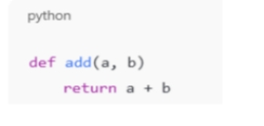

Output: -
Corrected function with syntax fix
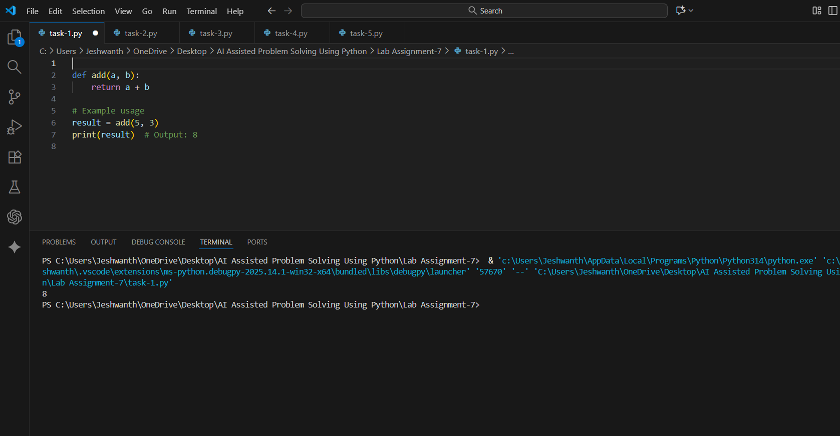

Task Description 2

Identify and fix a logic error in a loop that causes infinite iteration
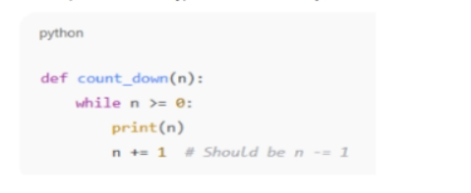
Output: -
● AI fixes increment/decrement error
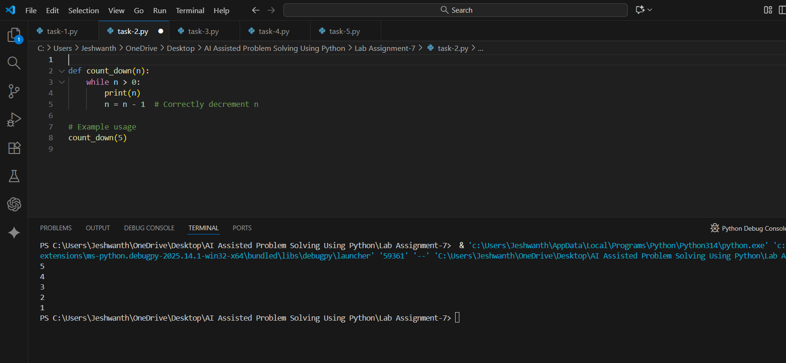

Task Description 3
Debug a runtime error caused by division by zero. Let AI insert try-except.
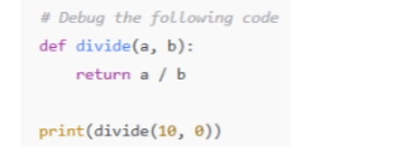
Output: -
Corrected function with safe error handling

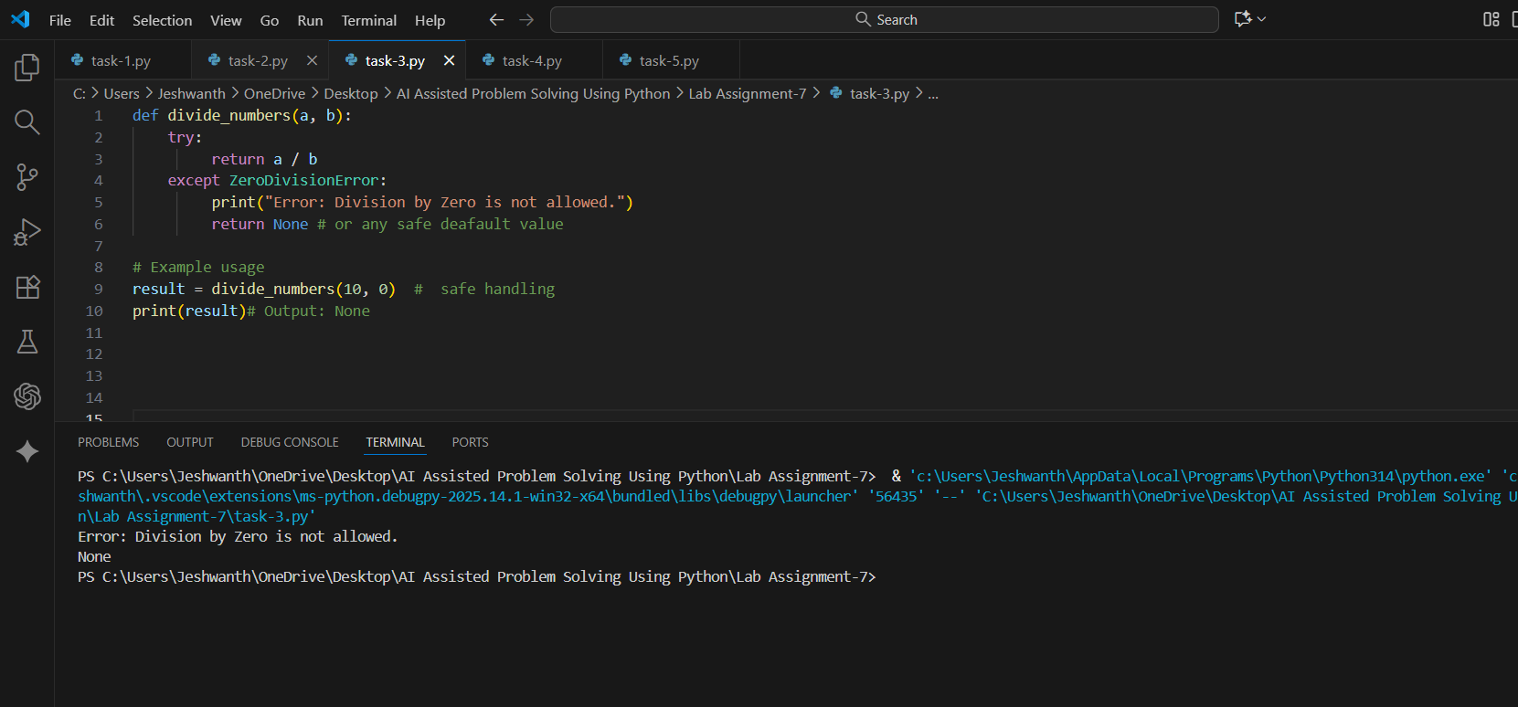

Task Description 4
Provide a faulty class definition (missing self in parameters). Let AI fix it
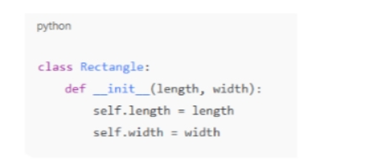

Output: -
● Correct _init_() method and explanation
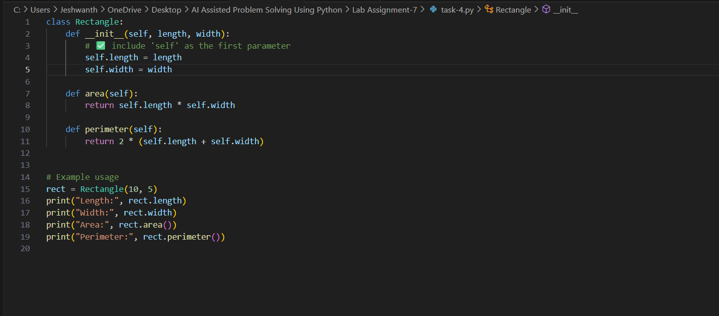
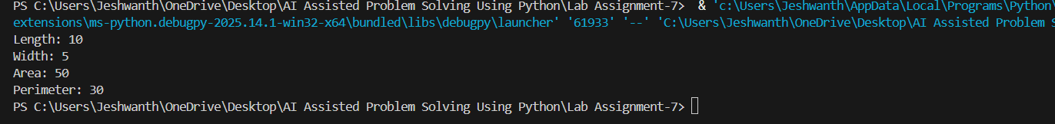
Explanation:-
1. Class Definition
class Rectangle:
This line defines a class called Rectangle.
A class is like a blueprint for creating objects — in this case, objects that represent rectangles.

🧩 2. The __init__ Method (Constructor)
def __init__(self, length, width):
self.length = length
self.width = width
- __init__ is a special method in Python that automatically runs when you create a new object from the class.
- self refers to the current object being created.
- length and width are parameters you pass when creating a Rectangle.
Inside the constructor:
- self.length = length stores the length value in the object.
- self.width = width stores the width value in the object.
So each rectangle object will remember its own length and width.

📐 3. Method to Calculate Area
def area(self):
return self.length * self.width
This defines a method (a function inside a class) to compute the area of the rectangle.
Formula:
$$\text{Area}=\text{length}×\text{width}$$
When you call rect.area(), it returns the area for that specific rectangle.

📏 4. Method to Calculate Perimeter
def perimeter(self):
return 2 * (self.length + self.width)
This defines another method that calculates the perimeter of the rectangle.
Formula:
$$\text{Perimeter}=2×(\text{length}+\text{width})$$

🧮 5. Example Usage
rect = Rectangle(10, 5)
This creates a new Rectangle object named rect with:
- length = 10
- width = 5

📊 6. Printing Results
print("Length:", rect.length)
print("Width:", rect.width)
print("Area:", rect.area())
print("Perimeter:", rect.perimeter())
Output:
Length: 10
Width: 5
Area: 50
Perimeter: 30

Task Description 5
Access an invalid list index and use AI to resolve the Index Error.
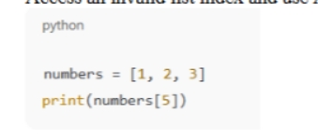
Output: -
